4.5.1 Packet Tracer - Inter-VLAN Routing Challenge
Addressing Table
Device | Interface | IP Address | Subnet Mask | Default Gateway
R1 | G0/0 | 172.17.25.2 | 255.255.255.252 | N/A
 | G0/1.10 | 172.17.10.1 | 255.255.255.0
 | G0/1.20 | 172.17.20.1 | 255.255.255.0
 | G0/1.30 | 172.17.30.1 | 255.255.255.0
 | G0/1.88 | 172.17.88.1 | 255.255.255.0
 | G0/1.99 | 172.17.99.1 | 255.255.255.0
S1 | VLAN 99 | 172.17.99.10 | 255.255.255.0 | 172.17.99.1
PC1 | NIC | 172.17.10.21 | 255.255.255.0 | 172.17.10.1
PC2 | NIC | 172.17.20.22 | 255.255.255.0 | 172.17.20.1
PC3 | NIC | 172.17.30.23 | 255.255.255.0 | 172.17.30.1
Server | NIC | 172.17.50.254 | 255.255.255.0 | 172.17.50.1

Addressing Table
VLAN | Name | Interface
10 | Faculty/Staff | F0/11-17
20 | Students | F0/18-24
30 | Guest(Default) | F0/6-10
88 | Native | G0/1
99 | Management | VLAN 99

Scenario
In this activity, you will demonstrate and reinforce your ability to implement inter-VLAN routing, including configuring IP addresses, VLANs, trunking, and subinterfaces.

Instructions
Configure the devices to meet the following requirements.

- Assign IP addressing to R1 and S1 based on the Addressing Table.
R1 | 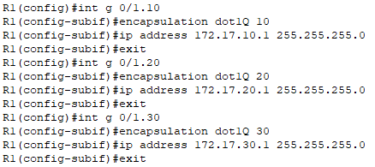  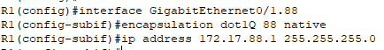  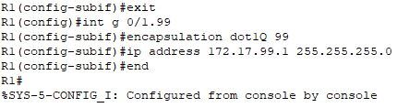  R1(config)#int g 0/1.10  R1(config-subif)#encapsulation dot1Q 10  R1(config-subif)#ip address 172.17.10.1 255.255.255.0  R1(config-subif)#exit  R1(config)#int g 0/1.20  R1(config-subif)#encapsulation dot1Q 20  R1(config-subif)#ip address 172.17.20.1 255.255.255.0  R1(config-subif)#exit  R1(config)#int g 0/1.30  R1(config-subif)#encapsulation dot1Q 30  R1(config-subif)#ip address 172.17.30.1 255.255.255.0  R1(config-subif)#exit  R1(config)#encapsulation dot1Q 88  R1(config)#int g 0/1.88  R1(config-subif)#encapsulation dot1Q 88 native  R1(config-subif)#ip address 172.17.88.1 255.255.255.0  R1(config-subif)#exit  R1(config)#int g 0/1.99  R1(config-subif)#encapsulation dot1Q 99  R1(config-subif)#ip address 172.17.99.1 255.255.255.0  R1(config-subif)#end  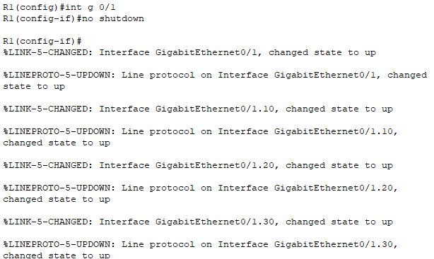  R1(config)#int g 0/1  R1(config-if)#no shutdown
S1 | 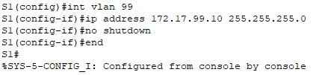  S1(config)#int vlan 99  S1(config-if)#ip address 172.17.99.10 255.255.255.0  S1(config-if)#no shutdown  S1(config-if)#end

- Configure the default gateway on S1.
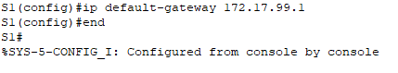
S1(config)#ip default-gateway 172.17.99.1

- Create, name, and assign VLANs on S1 based on the VLAN and Port Assignments Table. Ports should be in access mode. Your VLAN names should match the names in the table exactly.
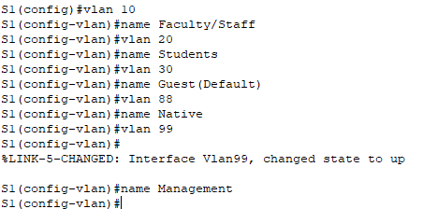
S1(config)#vlan 10
S1(config-vlan)#name Faculty/Staff
S1(config-vlan)#vlan 20
S1(config-vlan)#name Students
S1(config-vlan)#vlan 30
S1(config-vlan)#name Guest(Default)
S1(config-vlan)#vlan 88
S1(config-vlan)#name Native
S1(config-vlan)#vlan 99
S1(config-vlan)#name Management

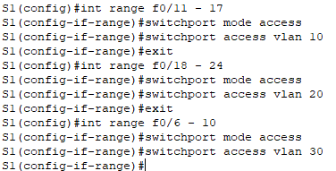
S1(config)#int range f0/11 - 17
S1(config-if-range)#switchport mode access
S1(config-if-range)#switchport access vlan 10
S1(config-if-range)#exit
S1(config)#int range f0/18 - 24
S1(config-if-range)#switchport mode access
S1(config-if-range)#switchport access vlan 20
S1(config-if-range)#exit
S1(config)#int range f0/6 - 10
S1(config-if-range)#switchport mode access
S1(config-if-range)#switchport access vlan 30

- Configure G0/1 of S1 as a static trunk and assign the native VLAN.
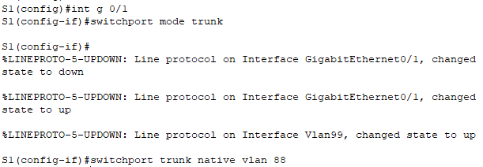
S1(config)#int g 0/1
S1(config-if)#switchport mode trunk
S1(config-if)#switchport trunk native vlan 88

- All ports that are not assigned to a VLAN should be disabled.
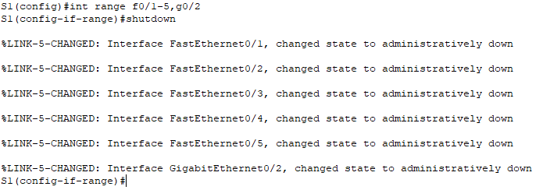
S1(config)#int range f0/1-5,g0/2
S1(config-if-range)#shutdown

- Configure inter-VLAN routing on R1 based on the Addressing Table.
- Verify connectivity. R1, S1, and all PCs should be able to ping each other and the server.

PC1 ping Server | 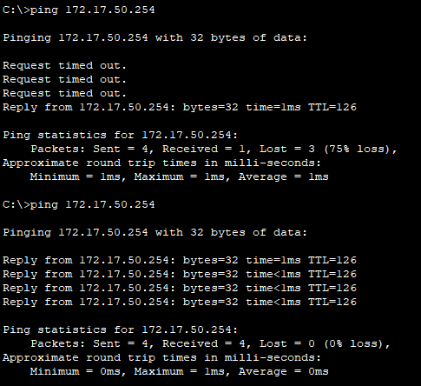
PC2 ping Server | 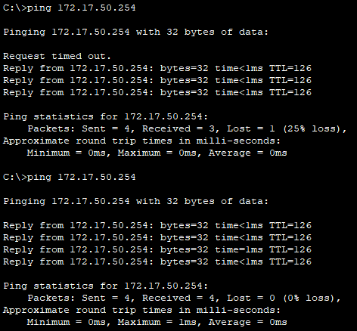
PC3 ping Server | 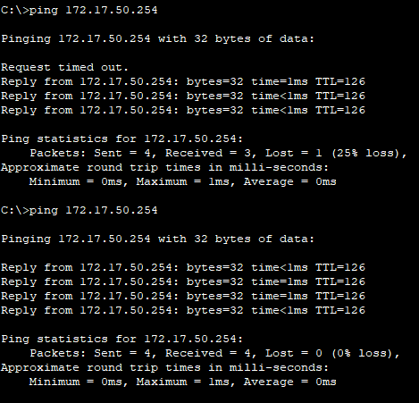
S1 ping Server | 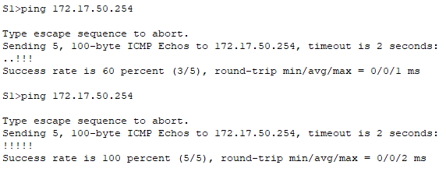
R1 ping Server | 